How to validate a CDA document
- Open your browser and please go to the following address:
https://gazelle.ehealth.brussels/EVSClient/home.seam
- Click on the menu icon


- Click on « Abrumet »



- Click on « CDA-Abrumet »

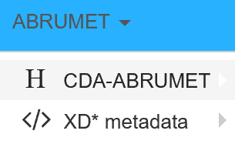

- Select « Validate »

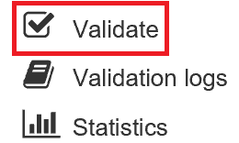

- Click on « Add » and select your CDA file previously generated by your program.

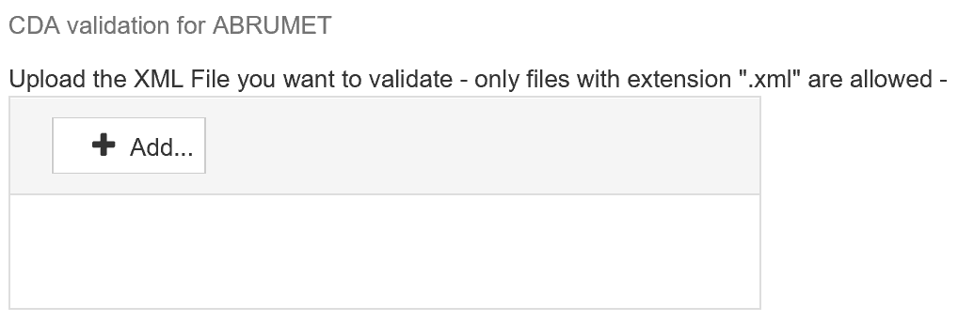
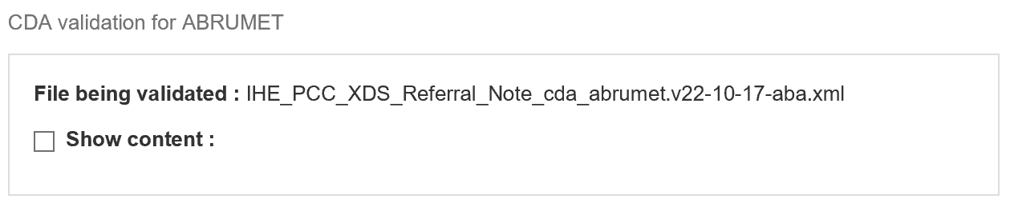

- If you wish, you always have the possibility to see the content of your file. To do this click on "Show Content" That will then appear in your browser.
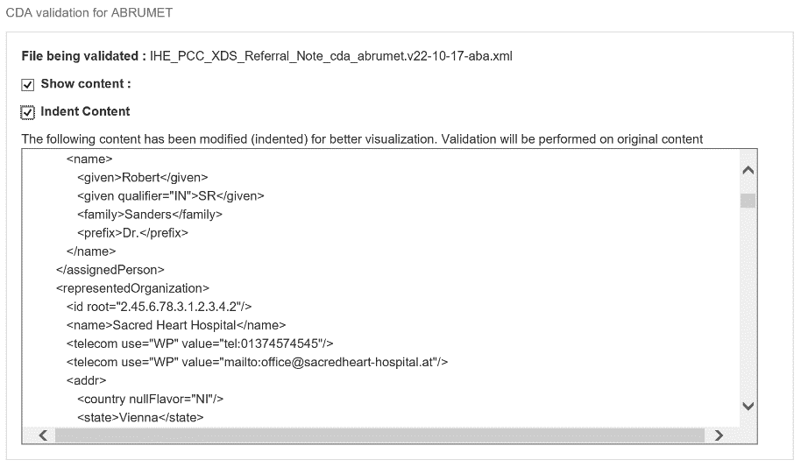

- Select your validation model. Your model must be validated to Abrumet standards, select "Abrumet - Referral Summary”.

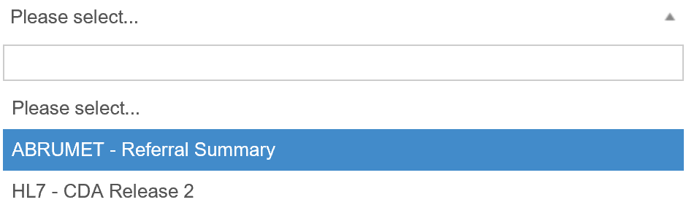

- Click on « Validate »



- Your CDA is being validated, it is done in three steps:
  - Validation of the XML structure

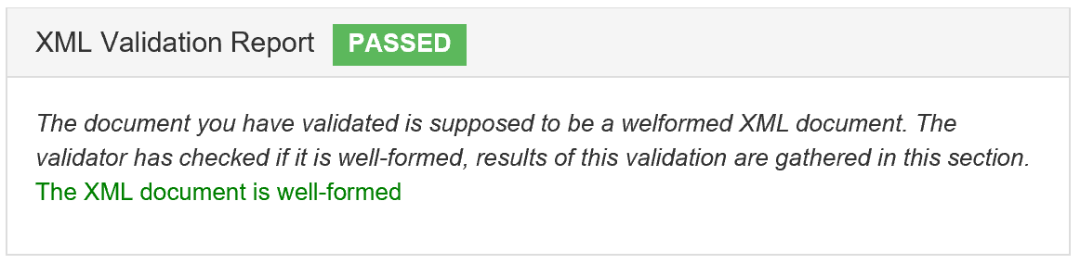

  - Validation of the XSD scheme

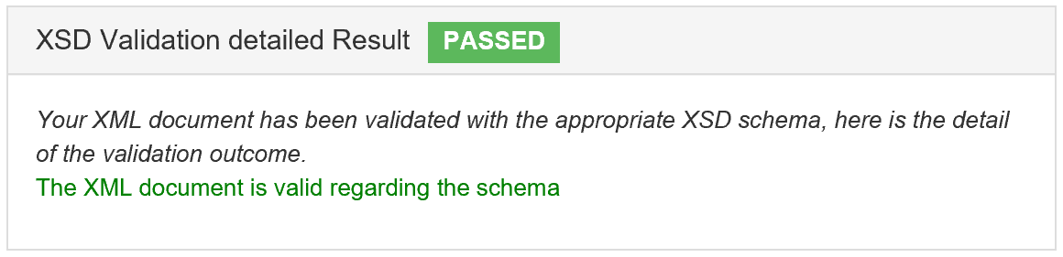

  - Validation of the model according to the Abrumet standard

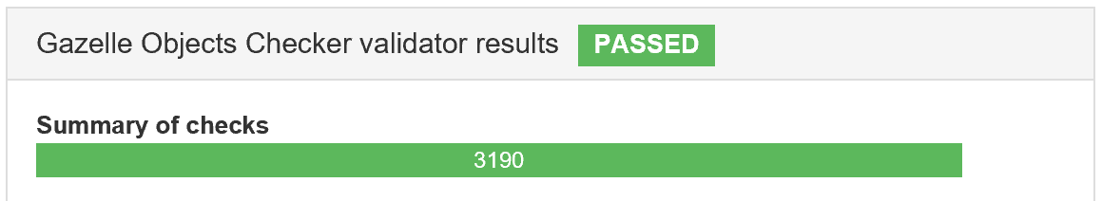

- Two posibilities at the end of the validation
  - either your file passes validation
  - your file does not pass validation

