Using the Referal Summary
- Open your browser and please go to the following address:
https://gazelle.ehealth.brussels/art-decor/decor-project--RS-

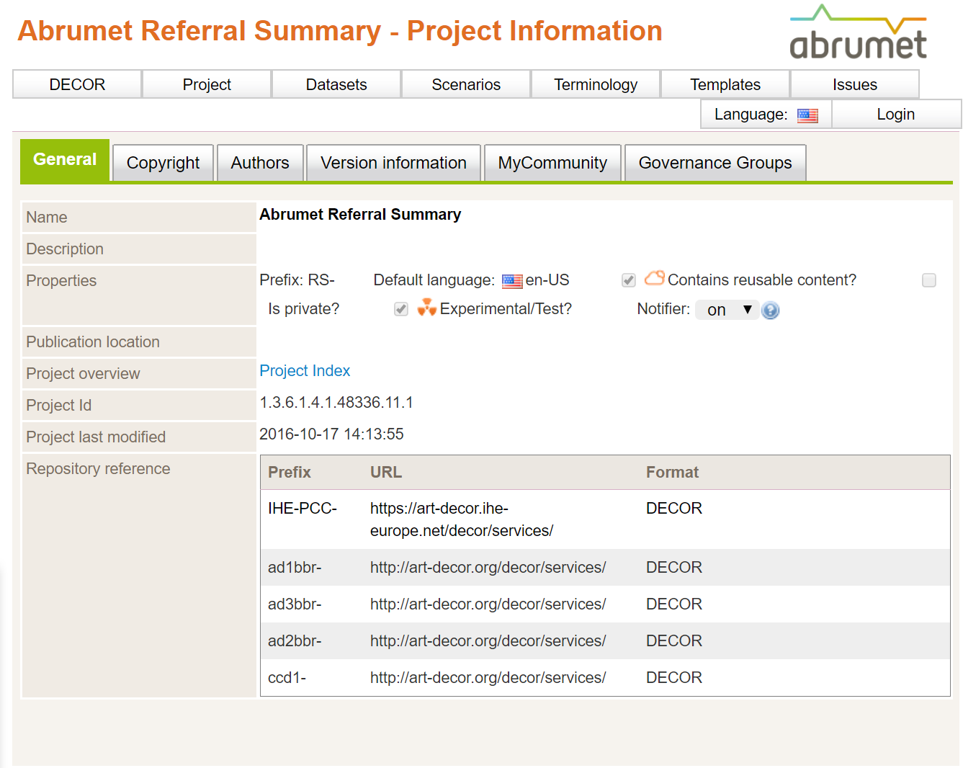

- Click on « Templates »

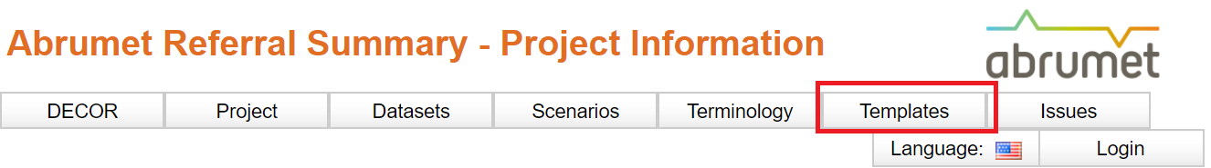

- Select « Abrumet Referral Sumarry Document (2014) »

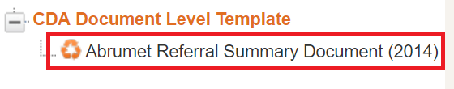

- You are now in the reference CDA document of Abrumet.

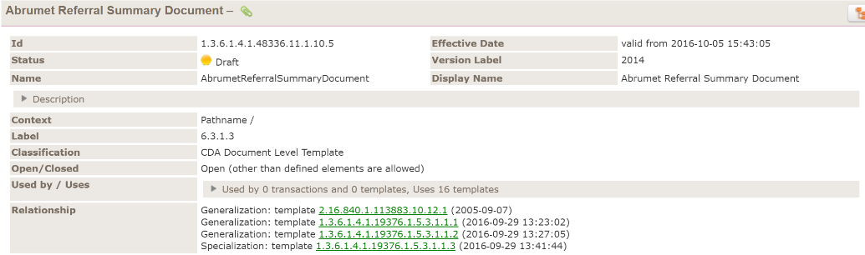

- It all includes the structure of your future CDA XML file. In the example below, you will find all the tags that the CDA XML file must include.

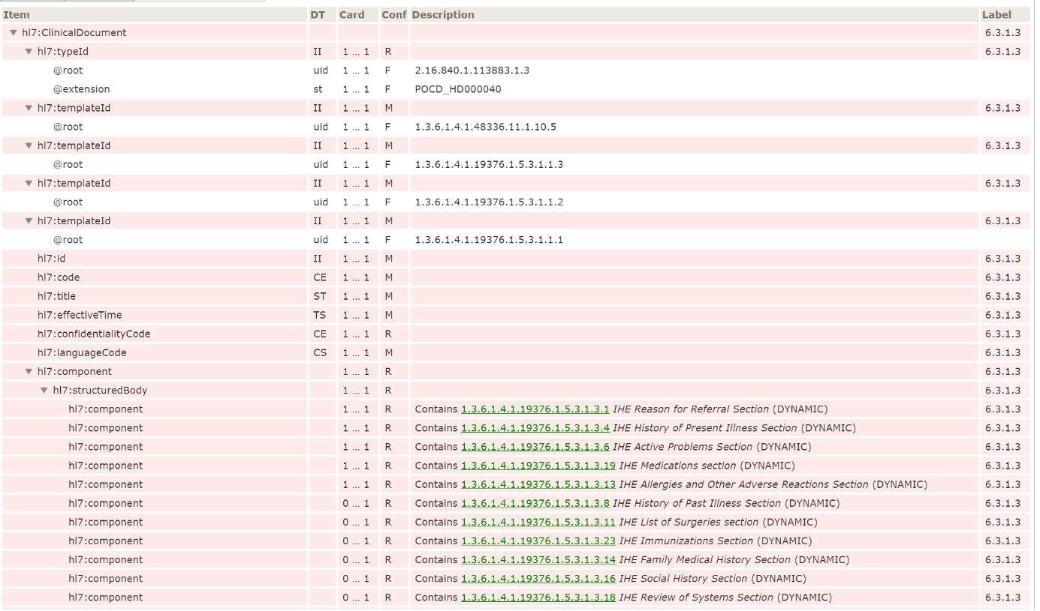
- The entire "structureBody" is subdivided into several "component" each useful for the medical record. If you want to have information on the template of a specific component, just click on it.

- So just click on one of these "component" to get information

