CDA

Overview
A CDA document is a definite and complete information object that can contain text, images, and other multimedia objects. CDA documents refer to a patient and consist of administrative (body or Header) and medical (body or Header) data. They are encoded in XML.

Basic Structure
The document structure must be validated like the CDA XML scheme. The document has the following XML structure:

<?xml version="1.0" encoding="UTF-8"?>
<?xml-stylesheet type="text/xsl" href="vhitg-cda-v3.xsl"?>
<ClinicalDocument
xmlns="urn:hl7-org:v3"
xmlns:voc="urn:hl7-org:v3/voc"
xmlns:xsi="http://www.w3.org/2001/XMLSchema-instance" xsi:schemaLocation="urn:hl7-org:v3 CDA.xsd">
<!-- Header CDA -->
<recordTarget>
<!-- The patient reference in the document -->
<patientRole>
<patient>
</patient>
</patientRole>
</recordTarget>
<!-- Person that created document content -->
<author>
<assignedPerson>
</assignedPerson>
<representedOrganization>
</representedOrganization>
</author>
<!-- Organization that maintains the document -->
<custodian>
<assignedCustodian>
</assignedCustodian>
</custodian>
<participant>
</participant>
<documentationOf>
</documentationOf>
<ComponentOf>
<!-- Clinical encounter during wich the service event occured -->
<encompassingEncounter>
<!-- Doctor information -->
</encompassingEncounter>
</ComponentOf>
<component>
<structuredBody>
<!-- Body CDA, Contains multiple section -->
<component>
<section>
<title>titre</title>
<text>
<!-- Free text -->
</text>
<entry>
<substanceAdministration>
<!-- Indication structurée des éléments PHR -->
</substanceAdministration>
</entry>
</section>
</component>
</structuredBody>
</component>
</ClinicalDocument>

Abrumet Referal summary
Each CDA XML document will have to take the nomenclature following Abrumet's "Referal summary", it can be found at the following address:
- https://gazelle.ehealth.brussels/art-decor/decor-project--RS-

Using the Referal Summary
- Open your browser and please go to the following address:
https://gazelle.ehealth.brussels/art-decor/decor-project--RS-

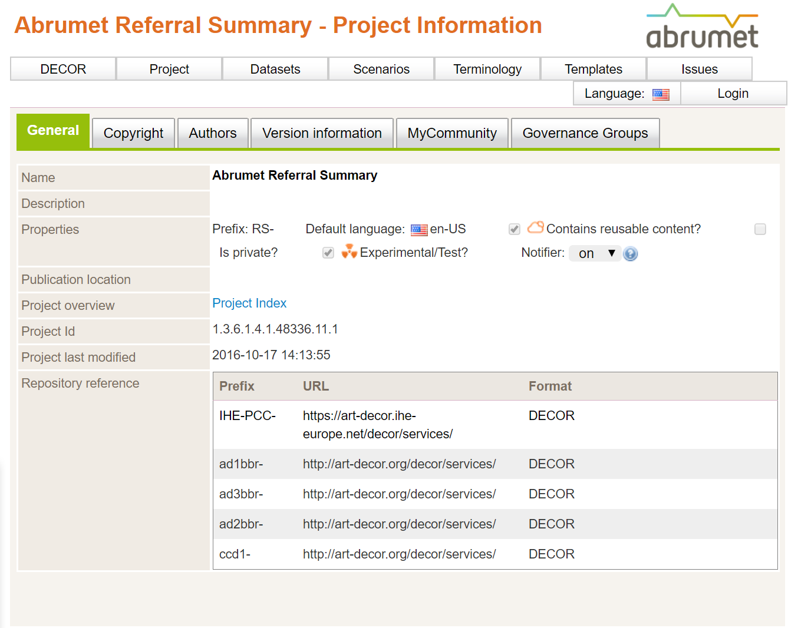

- Click on « Templates »

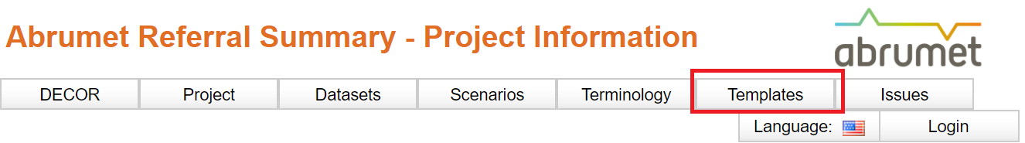

- Select « Abrumet Referral Sumarry Document (2014) »

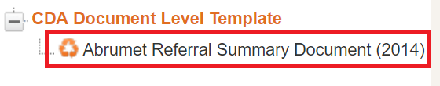

- You are now in the reference CDA document of Abrumet.

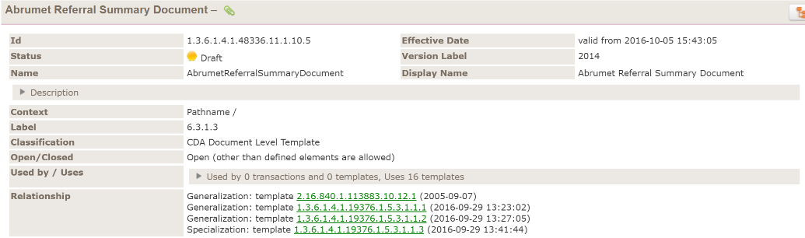

- It all includes the structure of your future CDA XML file. In the example below, you will find all the tags that the CDA XML file must include.

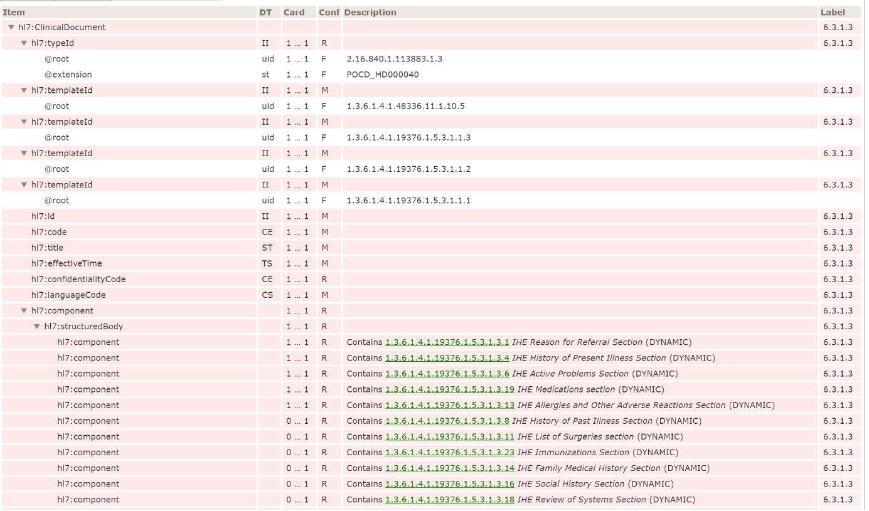
- The entire "structureBody" is subdivided into several "component" each useful for the medical record. If you want to have information on the template of a specific component, just click on it.

- So just click on one of these "component" to get information

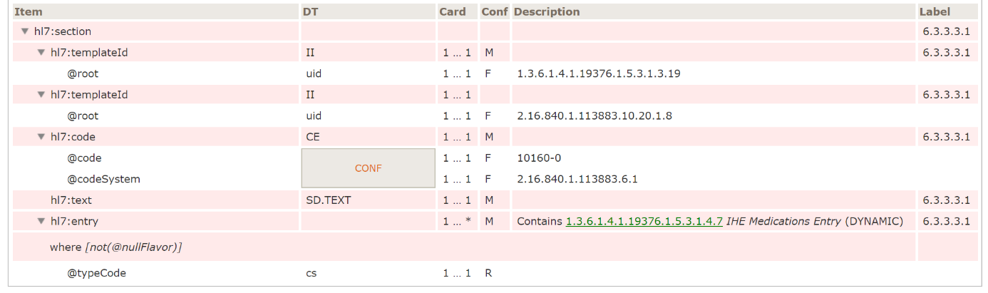

EVS Client
The EVS Client is a web application that allows users and developers of health applications implementing IHE profiles to verify the compliance of exchanged messages with reference to certain health standards. In our case, the health standard "HL7v3". It allows to validate the CDA and XDS formats of your applications based on Abrumet's "Abrumet Referal summary" nomenclature.

The web client is at the following address:

- https://gazelle.ehealth.brussels/EVSClient/home.seam

How to validate a CDA document
- Open your browser and please go to the following address:
https://gazelle.ehealth.brussels/EVSClient/home.seam
- Click on the menu icon


- Click on « Abrumet »



- Click on « CDA-Abrumet »

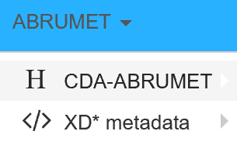

- Select « Validate »

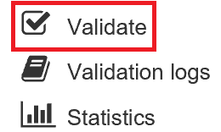

- Click on « Add » and select your CDA file previously generated by your program.

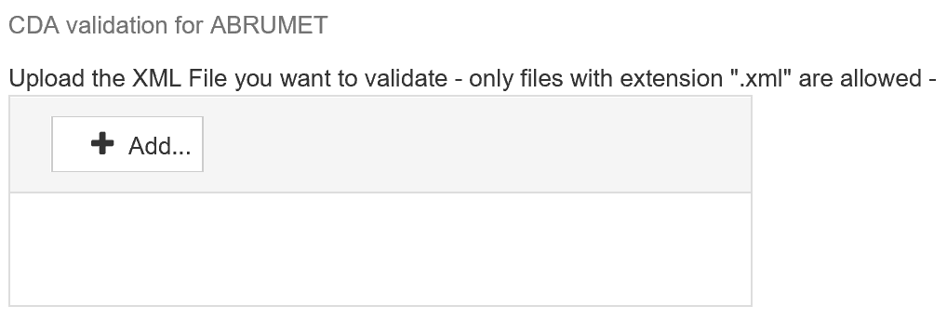
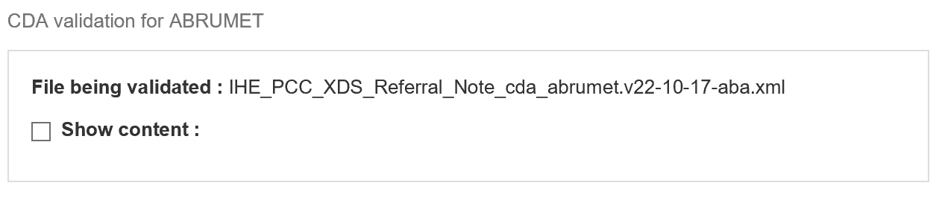

- If you wish, you always have the possibility to see the content of your file. To do this click on "Show Content" That will then appear in your browser.
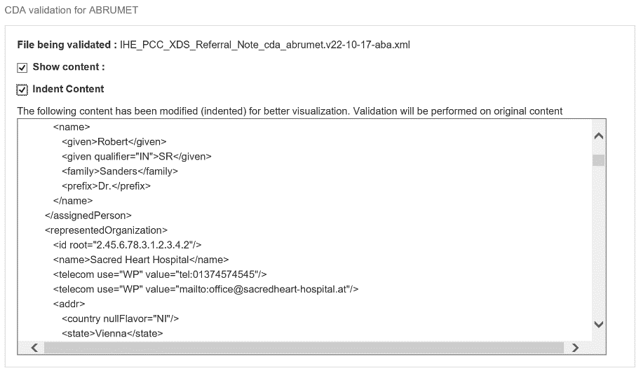

- Select your validation model. Your model must be validated to Abrumet standards, select "Abrumet - Referral Summary”.

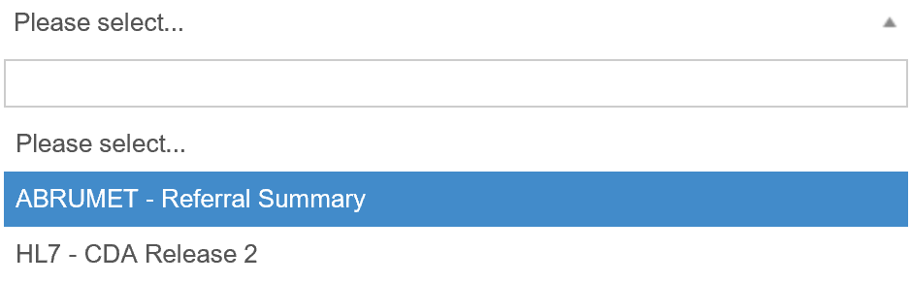

- Click on « Validate »



- Your CDA is being validated, it is done in three steps:
  - Validation of the XML structure

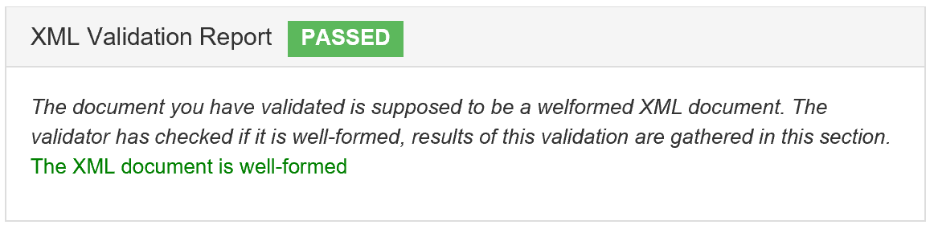

  - Validation of the XSD scheme

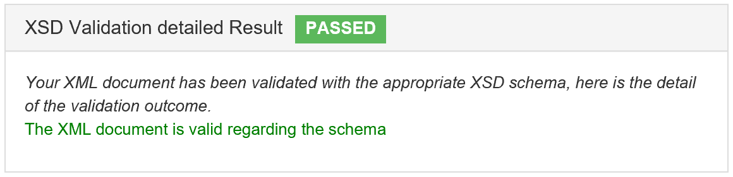

  - Validation of the model according to the Abrumet standard

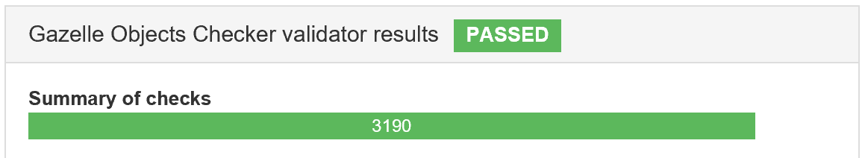

- Two posibilities at the end of the validation
  - either your file passes validation
  - your file does not pass validation

How to access the log history of a CDA document
- . Open your browser, and please go to the following address
https://gazelle.ehealth.brussels/EVSClient/home.seam
- Click on the menu icon

- Click on « Abrumet »

- Click on « CDA-Abrumet »

- Select « Validation logs »

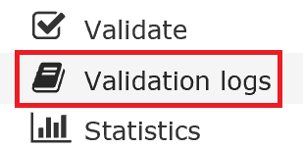

- The list of different public logs validated and not validated are displayed. You can of course be inspired by "passed" logs for your future CDA files.

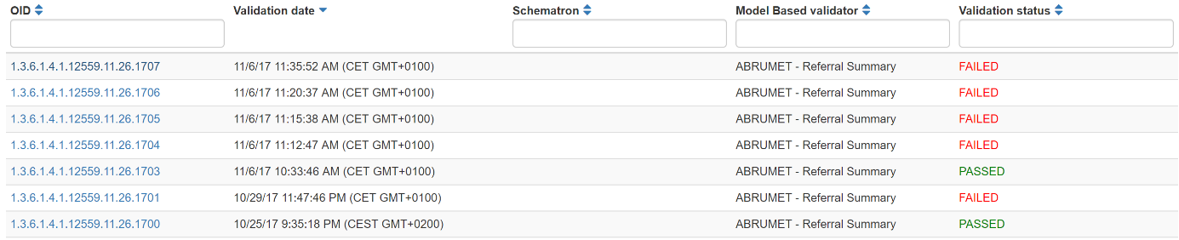

How to use the error logs of a non-validated CDA document.
- If your file does not pass the validation, the EVS client gives you all a series of tools allowing you to detect the problem.
- In the "Gazelle Objects Checker validator results" area, you can filter your logs according to various criteria such as error messages, warning messages, and so on.

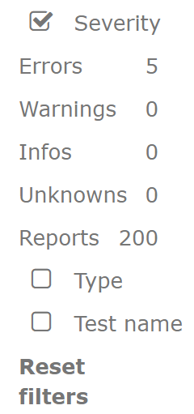

- The error list is displayed and the web client allows you to position yourself directly on the line where there is an error. To do this, click on the eye icon.

https://gazelle.ehealth.brussels/EVSClient/detailedResult.seam?type=CDA&oid=1.3.6.1.4.1.12559.11.26.1704

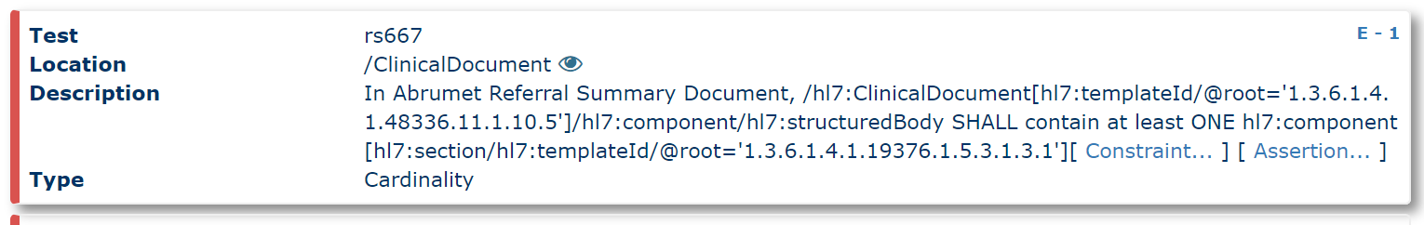

- In our case, the error returned is a missing "component" error with templateId "1.3.6.1.4.1.19376.1.5.3.1.3.1" at test number RS667. The developer will have to add to his CDA file a component with this id.

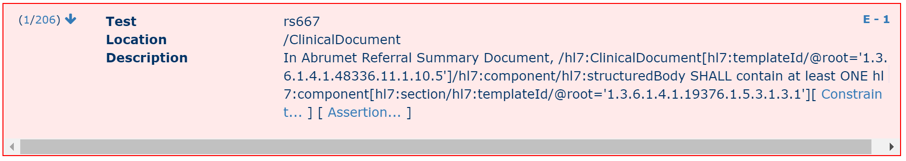

Below the correction made and the passage of the validation

<component>
<section>
<templateId root="1.3.6.1.4.1.19376.1.5.3.1.3.1"/>
<id root="1.2.40.0.13.1.1.10.10.30.98.20170322135345334.33588"/>
<code code="42349-1" codeSystem="2.16.840.1.113883.6.1" codeSystemName="LOINC" displayName="Reason for Referral"/>
<title>Reason for referral</title>
<text></text>
</section>
</component>

https://gazelle.ehealth.brussels/EVSClient/detailedResult.seam?type=CDA&oid=1.3.6.1.4.1.12559.11.26.1706

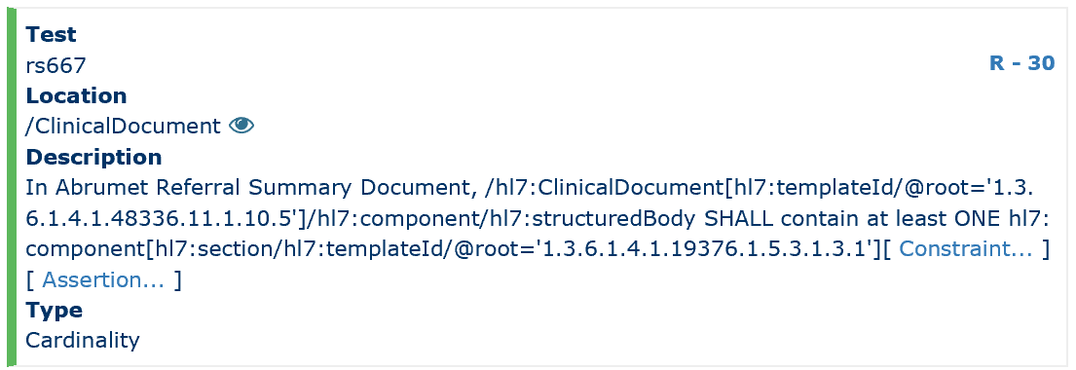

- Just repeat the operation to fix other errors linking to your CDA file. You can use the “Abrumet - Referral Summary” at any time to help you in the structure.

